# 4. Materials and Methodology

This thesis used a variety of socio-economic and health-related features to predict the national MMR estimate for each country, year sample. Estimates were generated for separate missing data and predictive analyses. Development of the final, highest performing model involved 4 major steps.

1. Applying cross-fold validation, feature selection, and missing data removal to generate different train datasets.
2. Training Random Forest, XGBoost, and LightGBM regressors on different versions of the train dataset to explore different pre-processing techniques.
3. Training stacking and voting ensemble models on different combinations of base estimators to reduce predictive error.
4. Evaluate best-performing model by analysing feature importance and sensitivity to input data as well as comparing its predictions to MMR estimates in the literature.

See Figure 2, below, for a more detailed overview of the method.

All code was written using Python3 and run in Visual Code Studio or on the Gadi supercomputer at the National Computational Infrastructure. Where appropriate, the random seed was set to 42 for reproducibility. All datasets and code used in this thesis were uploaded to a public GitHub repository (<https://github.com/R0sle/health_economics_honours>). Unfortunately, some of the datasets were too large to be uploaded. All datasets are available upon request.

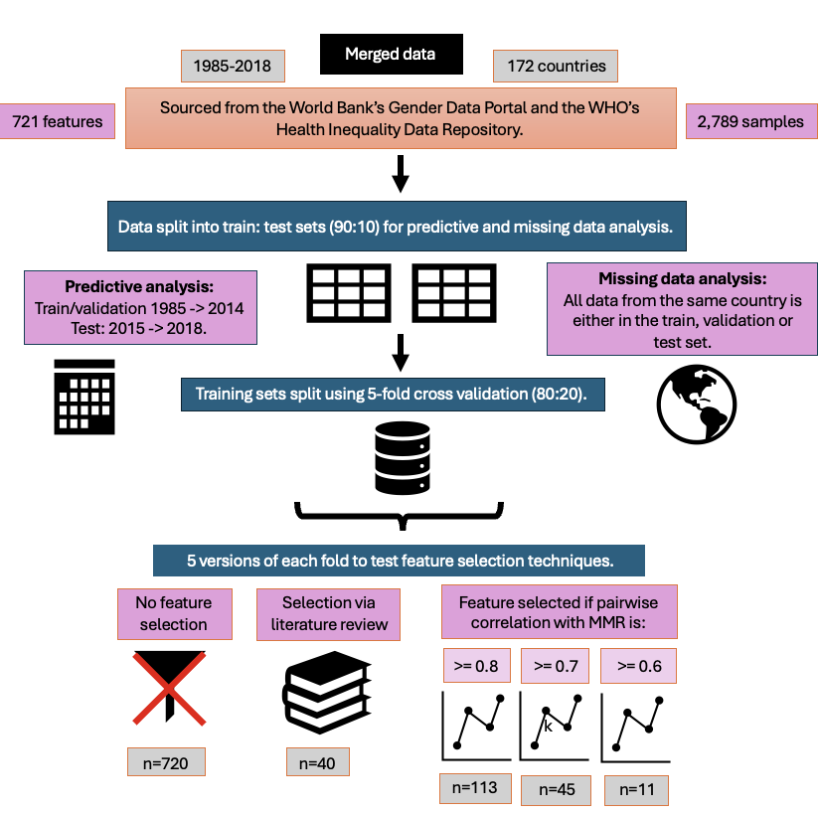

**Figure 2**: High-level overview of the process of generating train, validation and test datasets to fit and evaluate a variety of decision-tree based models. Data from the WHO and World Bank was merged into a single dataset before being split into train/test sets. Separate splits were conducted for missing data and predictive analysis. Each training set was further divided into 5 cross-validation folds. 5 versions of each fold were produced with different feature selection methods. Finally, four versions of each feature subset dataset were produced by removing missing data with different levels of flexibility. Each dataset was used to train a single Random Forest, XGBoost, and LightGBM model, with different combinations of these base estimators used to train ensemble models that produced the final MMR estimate.

## 4.1 Data Sources and Merging

### 4.11 Data Sources

Data was sourced from a variety of World Health Organisation (WHO) and World Bank Group repositories. The final merged dataset consisted of a mixture of socio-economic, health-related, and environmental indicators from a range of sources. Using data from a variety of data sources was motivated by comments made by Onambele et al. (2023), who recommended that future research into maternal mortality estimates combine data from multiple sources to take advantage of the different datasets offered by the WHO.

National MMR estimates were sourced from the World Bank Group’s Gender Data Portal (30). This dataset contains MMR estimates for 242 regions, countries, territories, and areas between 1985 and 2018. **These national MMR estimates served as the ‘ground truth’ in this study.**

Some of the datasets contained disaggregated data. For example, features were sex or economic status specific. However, the national MMR estimates were not disaggregated. Including the disaggregation as its own feature column would therefore produce a missing value in the associated MMR estimate column when merging the datasets. To prevent this, I created subgroup specific versions of the feature. See Table 2 for an illustrative example. If the data was disaggregated on a scale (e.g. Feature A was reported for wealth quintiles 1 through 5), I only used values from the most extreme subgroups (e.g. quintiles 1 and 5) to prevent the number of features, and thus the dimensionality of the dataset, from becoming too large.

**Table 1**: Illustrative example of subgroup specific versions of a single feature, ‘Feature 1’, with the bolded text defining the demographic being represented.

|  |  |  |  |  |  |  |  |
| --- | --- | --- | --- | --- | --- | --- | --- |
| Country | Date | Feature 1 **Female** | Feature 1 **Male** | Feature 1 **Rural** | Feature 1 **Urban** | Feature 1 **Wealth Quintile 1** | Feature 1 **Wealth Quintile 5** |
|  |  |  |  |  |  |  |  |
|  |  |  |  |  |  |  |  |

Information about the specific datasets used in this study was summarised in Table 2, below. See the GitHub repository for the specific variables gathered from each data source. Each of the individual features were collated by WHO technical programs [35].

**Table 2:** Summary information about the datasets used in this study.

|  |  |  |  |  |  |
| --- | --- | --- | --- | --- | --- |
| **Type of Dataset** | **Number of Features** | **Date Range** | **Number of Areas Covered** | **Demographic Subsets Used** | **Source** |
| National MMR estimates | 1 | 1985-2018 | 242 | NA | World Bank Group’s Gender Data Portal [30] |
| Health outcomes & literacy, agency | 198 | 1960-2023 | 265 | NA | World Bank Group’s Gender Data Portal [31] |
| Illness incidence and prevalence | 193 | 2000-2019 | 194 | Sex | WHO Health Inequality Data Repository & IHME [34] |
| Empowerment | 9 | 1991-2023 | 120 | Economic status (quintiles 1, 5) | WHO Health Inequality Data Repository after re-analysis by the WHO Center for Health Equity Monitoring [32] |
| Socioeconomic, education, environmental variables | 64 | 1970-2023 | 195 | Sex, economic status (quintiles 1 and 5), residence (urban, rural) | WHO Health Inequality Data Repository, sourced from the World Bank Data Catalogue [33] |
| World Bank’s Categorisation of a Country’s Income level | 1 | 2024 |  | NA | WHO Health Inequality Data Repository [35] |

### 4.12 Merging Data

All datasets used in this report contained columns specifying the country and its associated ISO3 country code, as described in the ISO 3166 international standard [36]. However, different datasets sometimes used a different version of the same country’s name (e.g. United States versus United States of America). Therefore, datasets were merged using the unique ISO3 code and year. The final merged data set had 16, 948 rows uniquely identified by their country and year, with 732 columns extracted from the original dataset.

The national MMR estimates were collected between 1985 and 2018. Therefore, all data collected before 1985 and after 2018 was excluded. Features with no data between 1985 and 2018 were also excluded. This restricted the dataset to 9,018 rows and 726 columns.

### 4.13 Data Cleaning

All year/country combinations that were missing national MMR estimate values were removed from the dataset. This avoided needing to impute the ground truth variable, which may have caused the models to be trained on incorrect feature/MMR estimate pairings, introducing inaccuracy. As a result, the number of rows in the dataset decreased from 9,018 to 2,789. This data cleaning step caused the number of samples from each income level to decrease, with greater proportional decrease observed for lower-income countries (see Table 3).

**Table 3:** Number of samples per income level before and after rows with missing MMR data were removed. The proportion of samples remaining after cleaning was given as a percentage.

|  |  |  |  |
| --- | --- | --- | --- |
| **Income Level** | **Number of Samples** | | **Proportion of Samples Remaining (%)** |
| **Before Removing Samples with MMR Missing** | **After Removing Samples with MMR Missing** |
| **Low** | 884 | 78 | 8.8 |
| **Lower-Middle** | 1734 | 310 | 17.88 |
| **Upper-Middle** | 1802 | 996 | 55 |
| **High** | 2176 | 1405 | 65 |

Additionally, I removed the following feature variables:

* 'Number of maternal deaths’
* ‘Lifetime risk of maternal death (1 in: rate varies by country)’
* ‘Lifetime risk of maternal death (%)’

The ‘number of maternal deaths’ is the numerator of the MMR. Similarly, the two features measuring the ‘lifetime risk of maternal death’, as a rate or percentage, are calculated using the MMR [UN MMEIG report]. The Pearson’s correlation coefficient between the MMR estimate and the ‘lifetime risk of maternal death (%) was 0.93, showing their strong positive correlation. Therefore, these three variables were excluded from the feature dataset to prevent the model from using them to predict the MMR instead of learning the relationship between MMR and socio-economic and health-related data.

The final data cleaning step involved removing the ‘country’ and ‘year’ as feature variables, instead using them as unique sample identifiers. This step was performed because ‘country’ and ‘year’ could introduce bias in the data, where the model learns the typical MMR for a country or year instead of learning to use the relationships between MMR and the features.

As a result of this pre-processing, **the final, merged dataset consisted of 2,789 samples and 721 columns (one output variable and 720 features).**

## 4.2 Exploratory Data Analysis

An initial exploratory data analysis was conducted to gain a better understanding of the dataset and motivate choice of pre-processing techniques.

### 4.21 Missing Data Analysis

While all samples with missing MMR data were excluded from analysis (as described in section 4.13), it was instructive to explore and discuss missing data occurrence in the MMR estimates. The proportion of missing MMR data per year was calculated for each income level between 1985 and 2018 (see Section 5.11). The proportion of missing feature data per year was also calculated to better understand the input data distribution. The results of this analysis were shown in Figure 3 below, as they motivated how train/test subsetting was conducted.

**Figure 3:** Proportion of missing feature data across all countries per year from 1985 to 2018.

Before 2000, the dataset had close to or greater than 90% missing data. Between 2000 and 2018, the dataset generally had between 80 and 90% missing data. For 4 years, the proportion of missing data was less than 50% (see Table 4, below). There was typically little difference between the proportion of missing feature data across the different income levels.

**Table 4:** Years with the lowest proportion of missing feature data, rounded to 2 decimal places.

|  |  |  |  |  |
| --- | --- | --- | --- | --- |
| **Date** | **Proportion of Non-Missing Data** | | | |
| **Low Income (%)** | **Lower-Middle Income (%)** | **Upper-Middle Income (%)** | **High Income (%)** |
| 2000 | 25 | 27 | 26 | 30 |
| 2005 | 32 | 33 | 32 | 35 |
| 2010 | 22 | 25 | 24 | 28 |
| 2015 | 24 | 25 | 24 | 27 |

Having a few years with substantially less missing data than the norm was likely due to a group of indicators being reported with a periodicity of 5 years. This pattern was considered when splitting the data into train/test subsets, where at least one year of low missing data was used in the test set (see Section 4.241).

No data imputation was used despite the high level of missing data. This was done to prevent imputation from introducing bias into the dataset, especially given the high level of missing data. More specifically, the pattern of missing data in this dataset would typically be categorised as ‘missing not at random’ (MNAR). In other words, the probability of data being missing relies on both observed and missing data, or on other, unobserved variables [2, 3]. This dataset would be considered MNAR because the probability of missing data is heavily related to the robustness of the country’s data collection systems, which is an unseen variable, but which may be related to a country’s MMR. In this case, handling the missing data would require observation of the unseen data, making it extremely difficult to impute the missing data without ignoring the important unseen data and introducing bias [2]. For example, removing all rows and columns with missing data or imputing the missing values based on the observed datapoints would bias the data toward countries reporting greater amounts of data. As a result, I only used ML models that could work missing data.

### 4.22 Key Statistics

To give deeper insight into the feature dataset, I presented key summary statistics about some of the features that the literature describes as having a particularly meaningful relationship with MMR (see Section 5.11). The proportion of missing data was calculated after data cleaning, explaining why the MMR estimates have a missing data proportion of 0%. Both mean and median were included to give an indication of outlier occurrence.

### 4.23 Principal Component Analysis

Principal component analysis (PCA) was employed for dimensionality reduction purposes. Rather than trying to visualise patterns by plotting all 721 feature dimensions, PCA was used to project samples into the 10 principal components that captured the maximum amount of total variance across the dataset.

PCA cannot be performed on a sparse dataset. Thus, Scikit Learn’s k-Nearest Neighbours imputation method was used to impute missing data before applying PCA [4]. This method imputed missing values using datapoints that were most similar to the sparse datapoint in their non-missing dimensions [4]. The data was standardised to a zero mean and unit standard deviation before applying the Scikit Learn PCA method [5]. This prevented variance calculations from being skewed by features with high magnitudes [5].

The variance captured by the top ten principal component was calculated and presented in Figure 4, below. The first principal component captured 31% of total variance in the dataset. The proportion of variance captured decreased sharply to 9 and 6% for the second and third principal components before levelling out at 1.7 to 3% for the remaining top ten principal components. Thus, using the first two principal components to represent the dataset would capture approximately 40% of the data’s total variance, providing an adequate representation for the purposes of exploratory data analysis.

**Figure 4:** Percent of total variance in the dataset captured by the top 10 principal components.

The input feature data was plotted across its two most important principal component axes, with samples being coloured according to their income level, MMR estimate, and year to better identify patterns and clusters in the data. See Section 5.12 for the results of the PCA analysis.

### 4.24 Correlation Analysis

Analysis of the pairwise correlations between specific features and the MMR estimates was used to inform feature selection strategies. While there were a broad range of correlations between features and the MMR, the frequency of correlations was not uniformly distributed (see Figure 5). More specifically, over 50% of the pairwise correlation coefficients were between -0.25 and 0.25. In contrast, approximately 2% of the pairwise coefficients were less than -0.75 or greater than 0.75. The low frequency of high magnitude pairwise correlations motivated the use of feature selection methods as a possible way to reduce overfitting to noise.

**Figure 5**: Pearson’s pairwise correlation coefficient between a specific feature and MMR plotted against the proportion of features in the cleaned dataset with this correlation coefficient.

## 4.3 Data Pre-Processing for Machine Learning Pipeline

See Figure 2 for a flowchart overview of the data pre-processing process. Different versions of the train dataset were produced to explore the effect of various pre-processing techniques. The distribution of data across the train and test sets was presented in Section 5.2 to give insight into model performance and generalisation.

### 4.31 Splitting Input Data into Train/Test Sets

The cleaned dataset was split into train/test subsets in two different ways, where separate train/test datasets were used for missing data analysis and predictive analysis (see Figure 6).

a)

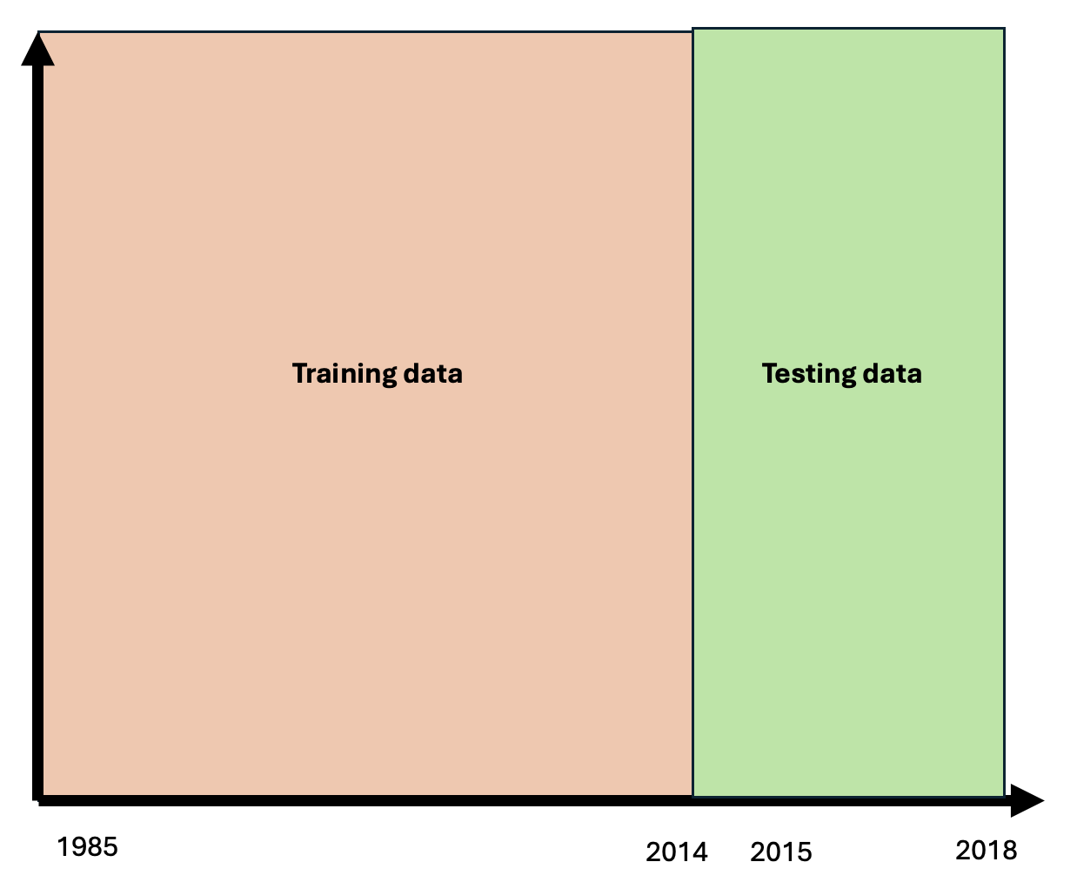

b)

**Figure 6:** Visualisation of train/test split for a) missing data analysis and b) predictive analysis.

#### 4.311 Missing Data Analysis (MDA):

The primary aim of this thesis was to predict MMR estimates for countries with sparse data. To achieve this purpose, I split the input dataset so all data from a specific country was in either the train or test set. This simulated the scenario where the model is trained on data from countries with data collection services and is then used to predict MMR estimates for countries with no data. Models trained in this way could inform policy makers about their country’s maternal health status. Additionally, splitting the input data by country prevented data leakage by preserving independence between the train and test sets.

Each country in the input dataset was classified as high-income, upper-middle income, lower-middle income, or low-income by the World Bank. I split the original dataset into 4 subsets, each containing all countries from a specific income level. Each of these subsets were split into train/test datasets in a 90:10 ratio. The 4 train sets were merged into one complete train set, and the 4 test sets were merged into a complete test set (see Figure 6a). This ensured that samples from each income level were in both the train and test sets to allow the test set to effectively evaluate whether the model could generalise to different income levels. However, ensuring all data from the same country was in either the train or test set meant the train/test split was not exactly 90:10. Instead, the true ratio was within one or two percent of 90:10, as the number of rows per country did not allow an exact 90:10 split.

#### 4.312 Predictive Analysis (PA):

Another aim in this thesis was to train models to forecast MMR. These forecasts could give policy-makers information about future MMR trends as well as allow researchers to predict the effects of candidate policies. I simulated this scenario by placing all data from 1985-2014 in the train set and all data from 2015-2018 in the test set (see Figure 6b). The goal of this strategy was for the model to learn patterns in the historical data to use to predict the future.

This division produced an 88:12 train/test split. I included data from 2015 in the test set to ensure the test set contained sufficient non-missing data to be useful, as 2015 was one of the four years containing less than 50% missing data (see Section 4.21).

### 4.32 Cross-Validation

Each of the MDA and PA train datasets were further divided into 5 cross-validation folds, each of which being a specific permutation of the train/validation 80:20 split.

If the data was being split for MDA, the same country was placed in either the train or validation set to prevent data leakage and evaluate the model’s ability to predict sparse country data. If the data was split for PA, the same year was placed in either the train or validation set to prevent data leakage and assess the model’s ability to predict for an unknown year. These conditions resulted in slight deviations from the 80:20 ratio, but only within a percentage point.

The train data was split into cross-validation folds using Scikit Learn’s GroupKFold method, which ensures that entries of the same group only appear in one validation set [15]. Members of the groups were countries for MDA and years for PA. This method ensured that the train and validation sets varied across the different folds, allowing me to assess how changes in the composition of the training dataset affected model performance.

### 4.33 Feature Selection

As discussed in the literature review, decision-tree based models can work with high-dimensional data. I tested whether this ability meant they achieved the greatest performance when using high-dimensional data, or if they achieved greater performance when working with a subset of features. This difference may be due to a higher number of features introducing noise, sparsity, and additional computational complexity, as discussed in Section 3.2.

I created 5 versions of each fold, each with a different selection of features (see Table 5 for a summary and the GitHub repository for a spreadsheet giving the specific features used in each subset). In the first case, no features were removed to evaluate model performance on the full feature dataset, which contained 720 features. To create the second feature subset, I surveyed a number of papers about maternal mortality to learn which features researchers believed most strongly influence MMR [7, 8, 9, 10, 11, 12, 13, 14]. As a result, I hand-picked 40 biological and socio-economic feature variables. While there were many other relevant features I could have chosen from the available dataset, I believed these covered the major MMR determinants.

The final three feature subsets were produced using the correlation between feature variables and MMR, as motivated by Section 4.24. More, specifically, I computed the pairwise Pearson’s correlation coefficient of all feature columns with the MMR estimate. I used the Pandas correlation method, which ignores rows where either feature pair has a missing value. I created a dataset containing features whose absolute pairwise correlation coefficient with MMR was at least 0.8. I produced two additional datasets containing features whose absolute correlation coefficient with MMR was at least 0.7 and 0.6, respectively. This allowed me to test the strength of correlation needed for the features to improve model performance.

**Table 5:** The 5 feature selection methods used to create 5 versions of each train fold.

|  |  |
| --- | --- |
| **Feature Selection Method** | **Number of Features** |
| No feature selection employed. | 720 |
| Hand-picked features that the literature believes have a strong influence on MMR [7, 8, 9, 10, 11, 12, 13, 14]. | 40 |
| All features whose absolute Pearson’s pairwise correlation coefficient with MMR >= 0.8 | 11 |
| All features whose absolute Pearson’s pairwise correlation coefficient with MMR >= 0.7 | 45 |
| All features whose absolute Pearson’s pairwise correlation coefficient with MMR >= 0.6 | 113 |

### 4.34 Iterative Removal of Rows and Columns with a Higher Proportion of Missing Data Than a Specific Threshold

As discussed in Section 4.21, the input data contained information missing not at random. In this case, imputation and/or data removal can introduce bias, as the presence of missing data may signal important information about the country’s health system dynamics. However, if the specific feature has a very high proportion of missing data, such as over 85%, the model may overfit to its small dataset. Therefore, I experimented with removing rows and columns with very high proportions of data. More specifically, I iteratively removed columns and rows that contained a higher proportion of missing values than a pre-defined threshold. Higher thresholds meant rows and columns with a greater proportion of missing values were kept in the dataset.

Given that removal of a sparse row could affect the proportion of missing data in a column, and vice versa, the removal of rows and columns was conducted iteratively until the dataset stabilised. Similarly, since each feature subset had a different number of columns, the iterative removal of missing data had to be performed per feature subset/fold pair, as the number of columns influenced the proportion of missing data per row.

Iterative data removal was performed per fold to prevent data leakage between the folds. This procedure was only applied to the training data, not the validation or testing sets. This allowed evaluation results from different training datasets to be compared. However, to allow the models to function, columns dropped from a model’s train set due to feature selection or missing data removal were also dropped from the validation and test sets.

I produced 4 versions of each feature subset/fold combination using missing data thresholds of 85%, 90%, 95%, and 100% (no missing data removed).

See Figure 7 below for a visualisation of how iterative data removal affected the size of the entire input dataset, which gives a rough idea of the effects of data removal per fold. My lowest missing data threshold of 85% still preserved a fair amount of missing data (61%), staying true to the data sparse conditions of countries without robust data collection systems. Higher missing data thresholds retained a larger number of rows and columns. Decreasing the missing data threshold from 95% to 90% had a large impact on the number of rows (2568 to 2070) but only a small effect on the number of columns (611 to 610), indicating that missing data was more likely due to a data-sparse sample than a data-sparse feature.

a)

b)

c)

**Figure 7:** The a) proportion of missing data, b) number of rows and c) number of columns remaining in the full input dataset (not split into folds or feature subsets) after missing data removal for thresholds between 50% and 100% (no missing data removed).

I did not use stricter missing data thresholds to avoid introducing bias via removing missing data, as discussed above. Additionally, lower missing data thresholds would have reduced the size of the dataset to 700 rows, which is relatively small, increasing the risk of overfitting.

### 4.35 Summary of Datasets Produced Via Pre-Processing

The cleaned data was split into train/test subsets in a 90:10 ratio, with different versions of the split being implemented for MDA versus PA. These subsets were each further split into 5 cross-validation folds. 5 versions of each fold were created by applying different feature selection mechanisms. Finally, 4 versions of each of each feature subset/fold combination was produced by applying iterative missing data removal with different thresholds of missing data allowed.

This produced 100 datasets for each of the missing data and predictive analyses.

## 4.4 Models Training and Fine-Tuning

### 4.41 Base Model Development

#### 4.411 Training and Fine-Tuning

Scikit Learn’s Random Forest Regressor, XGBoost’s XGBRegressor and LightGBM’s LGBMRegressor were trained to predict the MMR for a specific country, year datapoint [16, 17, 18]. 100 versions of each model type were trained for missing data analysis, with each version corresponding to one of the 100 versions of the train dataset produced during pre-processing. Another 100 versions of each model type were trained for predictive analysis.

The models’ hyperparameters were fine-tuned using the Optuna hyperparameter optimisation framework [19]. Finetuning occurred over 1,000 Optuna trials, where each trial represented a choice of values for the subset of hyperparameters being tuned. See Tables 6, 7, and 8 for the specific hyperparameters fine-tuned for each model type. All other hyperparameters were set to their default values. During each trial, the model being fine-tuned was fit to its associated train data using the chosen hyperparameter values. Its performance was evaluated by calculating the mean squared error (MSE) of its predictions on the associated validation fold. The set of hyperparameters with the lowest validation MSE across the 1,000 trials was saved and used to define the highest performing model.

This method produced 300 fine-tuned models (100 each of XGBoost, LightGBM, and Random Forest models) for the missing data analysis and 300 models for the predictive analysis. Thus, 600 models were fine-tuned in total, which took 1 to 2 days. Due to this computational demand, fine-tuning was conducted with only one metric as opposed to multiple metrics capturing different information. MSE was used because it heavily penalises outliers, which in this context would most likely be errors in the high MMR estimates for lower-income countries.

**Table 6:** Hyperparameter Tuning for Scikit-Learn’s Random Forest Regressor [16]

|  |  |  |
| --- | --- | --- |
| **Hyperparameter Name in Scikit-Learn** | **Hyperparameter Function** | **Range of Potential Values** |
| n_estimators | The number of trees. | 10 to 300 |
| max_depth | The maximum depth of trees. | 3 to 25 |
| min_samples_split | The minimum number of samples/rows for which an internal node can be split. | 2 to 10 |
| bootstrap | Whether each tree was trained on a random subset of samples. | True or False |
| max_samples | The proportion of the full dataset used to train each base estimator. This parameter was not used when bootstrap is set to False. | 0.01 to 1.0 |

**Table 7:** Hyperparameter Tuning for XGBoost’s XGBRegressor [17]

|  |  |  |
| --- | --- | --- |
| **Hyperparameter Name in XGBoost** | **Hyperparameter Function** | **Range of Potential Values** |
| n_estimators | Number of trees/boosting iterations. | 10 to 300 |
| max_depth | The maximum depth of trees. | 3 to 25 |
| learning_rate | Controls the extent to which each new tree influenced the model’s predictions. | 0 to 1 |
| reg_alpha | Constant used for L1 regularisation. | 0 to 0.001 |
| reg_lambda | Constant used for L2 regularisation. | 0 to 0.001 |
| booster | ‘gbtree’ was the XGBoost gradient boosting method. ‘dart’ modified ‘gbtree’ to randomly drop trees to reduce overfitting. | ‘gbtree’ or ‘dart’ |
| subsample | The proportion of data randomly chosen for each boosting iteration during training. | 0.1 to 1 |

**Table 8:** Hyperparameter Tuning for LightGBM’s LGBMRegressor [18]

|  |  |  |
| --- | --- | --- |
| **Hyperparameter Name in LightGBM** | **Hyperparameter Function** | **Range of Potential Values** |
| n_estimators | Number of trees/boosting iterations. | 10 to 300 |
| max_depth | The maximum depth of trees. | 3 to 25 |
| learning_rate | Controls the extent to which each new tree influenced the model’s predictions. | 0 to 1 |
| reg_alpha | Constant used for L1 regularisation. | 0 to 0.001 |
| reg_lambda | Constant used for L2 regularisation. | 0 to 0.001 |
| boosting | ‘gbdt’ was the LightGBM gradient boosting method. ‘dart’ modified ‘gbdt’ to randomly drop trees to reduce overfitting. | ‘gbdt’ or ‘dart’ |
| bagging_freq | Every k-th iteration, a random subset of data was used for the next k iterations of training. | 0 to 10 |
| bagging_fraction | Proportion of input data randomly chosen for training. Used if bagging_freq was not zero. | 0.1 to 1.0 |

#### 4.412 Testing and Comparison

The best performing hyperparameter values for each model were saved at the end of the Optuna fine-tuning process. When being evaluated, each model was re-fit on its associated training data using these hyperparameter values

The 300 fine-tuned models for missing data analysis were evaluated on the same test set, which had no missing data removed. The only difference between the test sets used for the various models was that each test set contained only the features included in the model’s training data.

The fine-tuned models were evaluated on the accuracy of their test set predictions. Specifically, the MSE, root mean-squared error (RMSE), mean absolute error (MAE), R2, and mean relative error of its test set predictions were calculated. Using a wide range of metrics enabled a more nuanced evaluation of the model’s performance, as the metrics placed different emphasis on outliers. The mean relative error was a symmetrical version of the mean absolute percentage error (MAPE) described in Section 2.3211. The formula for the mean relative error (Equation 11) modified the base MAPE formula (Equation 5) to adjust for its asymmetrically.

Each combination of model type, feature subset and missing data threshold had 5 associated training folds. The combination’s performance was the average test performance of the models trained on these folds. The performances of different combinations were then compared.

The 300 fine-tuned models for predictive data analysis were similarly evaluated and compared.

#### 4.413 Feature Importance Analysis

Each feature’s importance was calculated using the models’ in-built methods. Scikit Learn’s Random Forest Regressor used the mean decrease in impurity/MSE across the feature’s splits [16]. XGBoost used the mean decrease in loss across the feature’s splits taking into account information from the loss function’s derivatives [17]. LightGBM calculated feature importance in a similar way to XGBoost but used the total decrease in loss rather than the average decrease [17, 18]. Feature importance was used to determine which variables had the highest predictive power for MMR, which was one of the primary aims of this thesis. Additionally, variation in feature importance across models was used to investigate differences in model performance.

### 4.42 Development of Voting and Stacking Ensemble Models

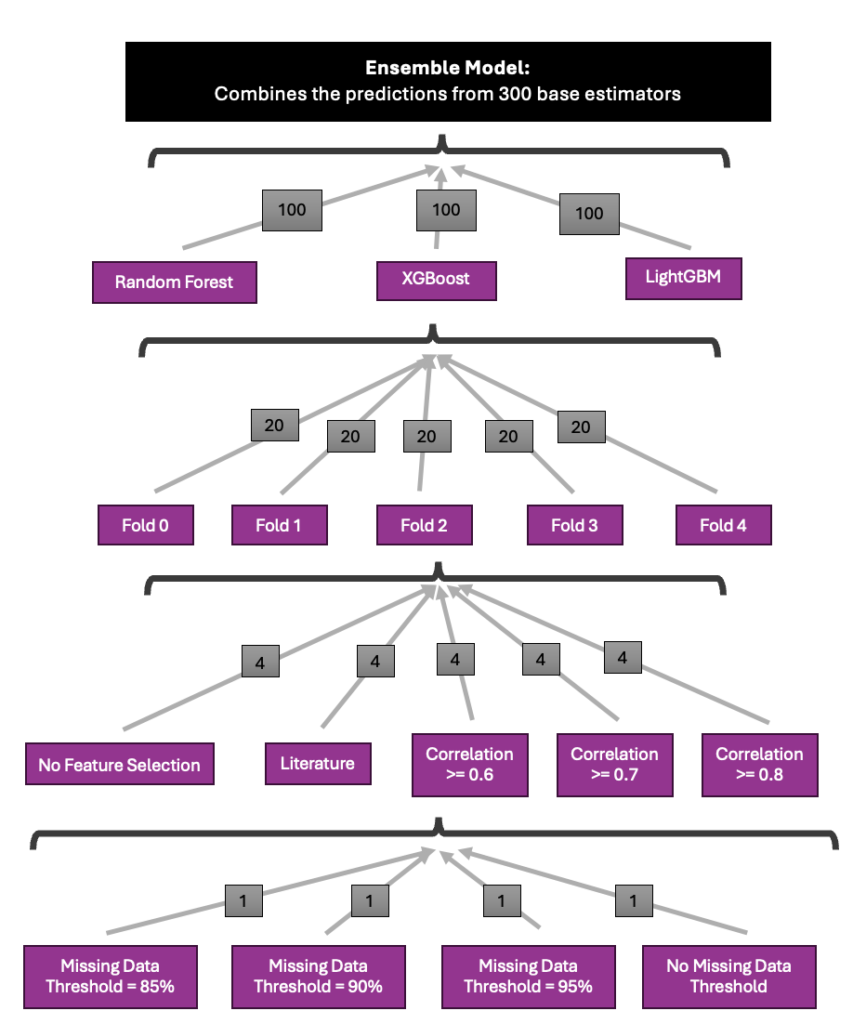

a)

b)

c)

d)

**Figure 8:** Visualisation of where the 300 base estimators used as input into the ensemble models came from. The grey boxes gave the number of base estimators trained per method. The 300 base estimators consisted of 100 Random Forest, XGBoost, and LightGBM models (a). 20 versions of each model-type were trained on each cross-validation fold (b), with the 4 models from the same fold trained on different feature subsets (c). Each of these 4 models were trained on a dataset with a different missing data threshold (d).

The ensemble modelling process detailed below was performed for both the missing data and predictive analyses. See Figure for a visualisation of the ensemble models’ inputs.

#### 4.421 Using all Base Predictors in Different Types of Voting and Stacking Ensemble Models

Each country, year sample in the input dataset was associated with a single ground truth MMR estimate. Using the previously described method, the 300 fine-tuned models would each predict sample’s MMR, giving 300 predictions per sample. The ensemble model treated each prediction as a feature, learning how to combine the 300 features to produce a final, accurate MMR estimate (see Figure 8a). For the remainder of the thesis, the component fine-tuned models used as input into the ensemble were referred to as “base estimators”.

More specifically, the base estimators were fit on their associated training data using their best hyperparameter settings, which were determined through the fine-tuning process described above. Then, each of the fine-tuned models predicted the MMR for the full, concatenated training and validation sets. In other words, the fine-tuned models predicted on the training data before it was exposed to cross-fold validation, feature selection, and missing data removal. These predictions served as the training dataset for the ensemble models.

I used voting and stacking ensemble models to combine the base estimators’ predictions, as a review of ensemble methods given in Section 3.31 found that, of all models tested within a study, voting and stacking ensembles most frequently had the highest performance [20].

#### 4.4211 Voting Ensemble

The voting ensemble model produced a weighted average of the base estimators’ predictions for each country, year sample. The weighting given to each base model was determined through 1,000 Optuna fine-tuning trials, with weights ranging from 0 to 1. The weights that produced the lowest MSE on the ensemble training data were chosen as the optimal hyperparameters. No validation set was used because the voting ensemble was not ‘trained’, it was simply given different sets of weights to use to combine the various base estimators. Thus, the ‘training data’ served the same function as ‘out of sample validation data’, as it was ‘unseen’ by the ensemble.

#### 4.4212 Stacking Ensemble

The stacking ensemble method uses a meta-learner, which itself was an ML model. This meta-estimator learned how to combine the predictions from the 300 base estimators to produce the lowest predictive error. I created three versions of the stacking ensemble to compare the performance of different meta-estimators. More specifically, I used the Elastic Net linear regression model, Random Forest regressor, and Support Vector Regressor as candidate meta-learners. All models were used with the Scikit Learn’s implementation [22, 16, 23]. Elastic Net was used as a progression of the voting ensemble model, where the combination of L1 and L2 regression could both perform feature selection and reduce the possibility of overfitting, as described in the background [24]. Additionally, as described in the literature review, decision-tree based stacking ensembles outperform base estimators solely based on bagging and boosting, thus motivating use of the Random Forest regressor as a meta-learner [26]. Support vector regression was used as a meta-learner because its approach of only using datapoints outside its error tolerance margin could have interesting effects on how it uses the predictions from different base learners [25].

Each meta-estimator had internal parameters that needed to be tuned, rather than just hyperparameters like in the case of the voting ensemble (see Table 9 for a description of the hyperparameters tuned for each meta-learner). As a result, the training dataset had to be split into train/validation sets. This allowed the stacking ensemble models to fit their internal parameters on the train set and fine-tune their hyperparameters on the validation set over 1,000 Optuna trials. The ensemble training data was split into train/validation sets in an 80:20 ratio using Scikit Learn’s ‘train_test_split’ method [21]. The hyperparameter values that produced the lowest MSE on the validation set were used in the final stacking ensemble models.

**Table 9:** Hyperparameters Tuned for Each Stacking Ensemble Meta-Estimator

|  |  |  |  |
| --- | --- | --- | --- |
| **Ensemble Model** | **Hyperparameter Name** | **Hyperparameter Function** | **Range of Potential Values** |
| Elastic Net Stacking Ensemble | Alpha | Specifies the extent of regularisation. | 0.1 to 1 |
| L1_ratio | Controls the weighting of the L1 versus L2 norm. Higher values push the regulariser closer to the L1 norm. | 0 to 1 |
| Random Forest Stacking Ensemble | Same parameters as described in Table 6. | | |
| Support Vector Machine Stacking Ensemble | kernel | Type of kernel used to transform input into a non-linear space. If ‘poly’, degrees tested were 2-5. | ‘poly’ (polynomial) or ‘rbf’ (radial basis function) |
| C | Strength of regularisation term | 0.1 to 1 |
| epsilon | Error tolerance, used to determine support vectors. | 0.05 to 1 |

#### 4.422 Evaluating the Voting and Stacking Ensemble Models

A test set was generated to be able to evaluate the voting and stacking ensembles’ predictive performance on out-of-sample data. The ensembles’ input test data consisted of the base estimators’ predictions on their test sets. The ensemble models used these predictions to give final MMR estimates, which were compared to the test ground truth. The ensembles’ models’ test performance was used to assess their generalisability and determine the best ensemble.

#### 4.423 Using the Best Performing Voting/Stacking Ensemble to Test Different Combinations of Base Estimators

After establishing the best performing voting or stacking ensemble, I tested whether its performance could be improved by using different combinations of base estimators. I compared its test performance when its input dataset only consisted of predictions from the following combinations of base estimators.

* 300 base estimators consisting of XGBoost, LightGBM, and Random Forest regressors (original ensemble model).
* 100 base estimators consisting of just XGBoost regressors.
* 100 base estimators consisting of just LightGBM regressors.
* 100 base estimators consisting of just Random Forest regressors.

This investigation was made for both the missing data and predictive performance analyses.

#### 4.424 Analysis of Base Estimator Importance

To better understand the variation in the ensemble models’ predictive performance, I explored how each ensemble valued the contribution of the various base estimators. More specifically, I investigated whether different ensemble models placed the most importance on predictions from the same set of base estimators or on different base estimators.

As described earlier, the different base estimators can be thought of as “features” in the ensemble model. Thus, the importance placed on each base estimator by the ensemble model was quantified using the model’s built-in feature importance methods. Model importance in the Random Forest ensemble was determined using the same Scikit Learn feature importance calculation described in Section 4.413 [16]. The weighting of each base estimator in the voting ensemble’s final prediction was used as a proxy for model importance. Similarly, base estimator importance in the Elastic Net model was determined using the coefficient attached to each base estimator’s predictions.

#### 4.425 Uncertainty Analysis

There were 300 base estimator predictions for each ground truth MMR estimate. I calculated the standard deviation among the 300 predictions for every datapoint in the test set to explore the base estimators’ agreement on the true MMR prediction. Lack of consensus among the base predictors would likely make the ensemble’s prediction less stable. As a result, this analysis provides an approximation for uncertainty in the ensemble’s predictions.

## 4.5 Sensitivity Analysis

I conducted a sensitivity analysis to gain a deeper understanding of how the input dataset affected the quality of the best performing ensemble’s predictions. The sensitivity analysis was conducted using the same procedure for the missing data analysis and predictive analysis models. See Figure 9 for a summary for the sensitivity analysis procedure.

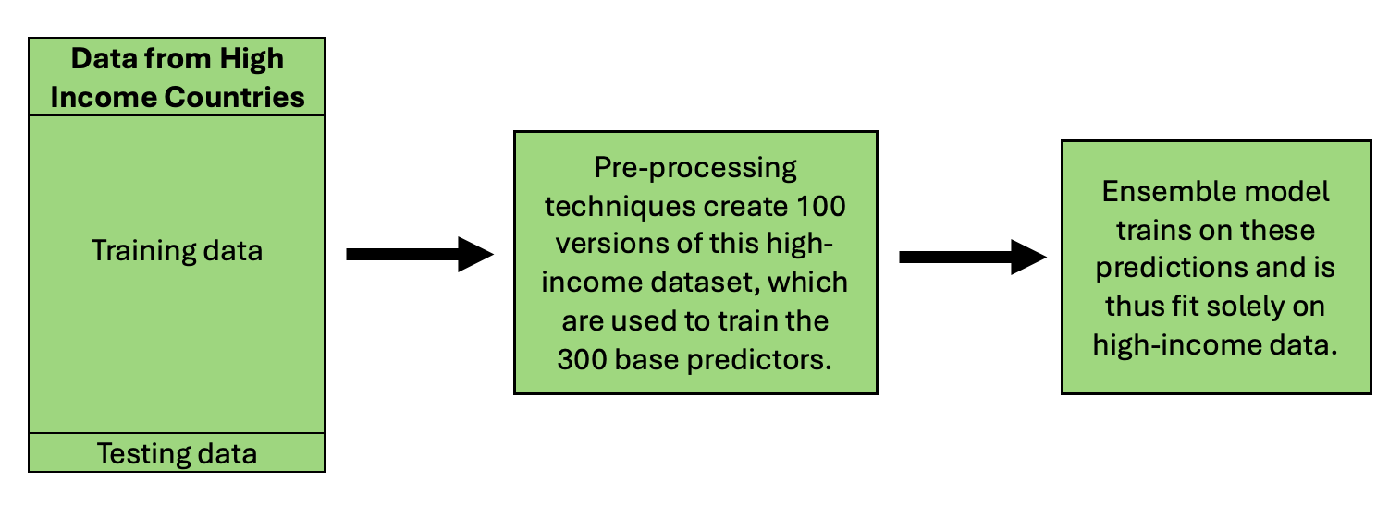

**Figure 9:** Visualisation of the sensitivity analysis procedure, where the ensemble’s base estimators were only fit on data from a single income level (in this case, high-income). The sensitivity analysis created a separate ensemble model for each income-specific version of the input dataset.

To perform the sensitivity analysis, I created 4 new versions of each fold/feature subset dataset by filtering the input dataset by income level. I then conducted missing data thresholding on each filtered dataset, as above. The filtered datasets were referred to as “sensitivity datasets” from this point forward, with the four filtered datasets characterised in the following list. This process generated 300 base estimators trained on each sensitivity dataset.

* Data from low-income countries only.
* Data from lower-middle income countries only.
* Data from upper-middle income countries only.
* Data from high-income countries only.

Each sensitivity analysis ensemble was fit on the base estimators’ predictions for a filtered version of the concatenated train, validation data, which only contained data from the relevant income level. Fine-tuning followed the same procedure described in Section 4.411.

The sensitivity analysis ensemble models were then evaluated using a version of the test dataset filtered to only contain data from the relevant income level. Each sensitivity analysis ensemble was compared to the original best performing ensemble, which was trained on data from all income levels but only used to predict on the filtered test set. For example, the sensitivity analysis ensemble trained and tested on data from low-income countries was compared to the original ensemble trained on all data but tested on data from low-income countries. Using the same test set ensured comparability between the original and sensitivity analysis models.

## 4.6 Comparison to Literature

I compared my best performing ensemble, trained on data from all income levels, to the latest versions of the GMatH simulation model, UN MMEIG’s BMat model, and GBD Study’s CODEm model. More specifically, I compared my model’s MMR predictions for each country/year sample to the predictions made by models described in the literature [27, 28, 29]. The MMR estimates from the literature were given with their 95% confidence intervals.

First, I calculated the percentage difference between my test set MMR estimates and the corresponding estimates from each literature model using Equation 12, below. This gave an indication of the similarity between my MMR estimates and the literature’s MMR predictions.

Then, I determined the percentage of test set MMR estimates from my best performing ensemble that fell in the 95% confidence interval of the corresponding estimates from the literature. This analysis was performed for all test set estimates and per income level, where I calculated the proportion of test set estimates for countries from a particular income that fell within the 95% confidence intervals of the associated estimates from the literature. I also calculated the proportion of ground truth MMR estimates used to test my model that fell within the 95% confidence interval of the literature models’ estimates. This compared the MMR estimates that my model was trained to predict with the literature’s MMR estimates to provide more information about whether differences between my model and the literature were due to poor performance or training data.

Finally, I visualised the difference between my model’s MMR estimates and the literature’s estimates for an exemplar country from each income level. I visualised the model’s estimates from the train set and test set separately to explore any possible difference. I attempted to maximise geographic coverage by comparing estimates for at least one country in the Americas, Africa, Europe, Oceania, and Asia.

Citations

1. Onambele, L.; Guillen-Aguinaga, S.; Guillen-Aguinaga, L.; Ortega-Leon, W.; Montejo, R.; Alas-Brun, R.; Aguinaga-Ontoso, E.; Aguinaga-Ontoso, I.; Guillen-Grima, F. Trends, Projections, and Regional Disparities of Maternal Mortality in Africa (1990–2030): An ARIMA Forecasting Approach. Epidemiologia 2023, 4, 322–351. https://doi.org/ 10.3390/epidemiologia4030032
2. <https://link.springer.com/article/10.1186/s40537-021-00516-9>
   1. Journal of big data
   2. Missing data mechanisms
3. <https://link.springer.com/article/10.1007/s40273-023-01297-0#Sec2>
   1. More about missing data mechanisms
4. <https://scikit-learn.org/stable/modules/generated/sklearn.impute.KNNImputer.html>
5. <https://scikit-learn.org/stable/modules/generated/sklearn.decomposition.PCA.html>
6. <https://www.nature.com/articles/s41592-018-0019-x>
   1. Curse of dimensionality
7. <https://jmai.amegroups.org/article/view/8590/html>
8. <https://www.sciencedirect.com/science/article/pii/S0169023X23000587?pes=vor&utm_source=scopus&getft_integrator=scopus>
9. <https://iris.who.int/bitstream/handle/10665/381012/9789240108462-eng.pdf?sequence=1>
10. <https://onlinelibrary.wiley.com/doi/10.5694/mja2.52452>
    1. Non-communicable disease and pregnancy
    2. Ramson et al., 2024
11. Akselrod S, Banerjee A, Collins TE, Acharya S, Artykova N, Askew I, Berdzuli N, Diorditsa S, Eggers R, Farrington J, Jakab Z, Ferreira-Borges C, Mikkelsen B, Azzopardi-Muscat N, Olsavszky V, Park K, Sobel H, Tran H, Vujnovic M, Weber M, Were W, Yaqub N, Berlina D, Dunlop CL and Allen LN (2023) Integrating maternal, newborn, child health and non-communicable disease care in the sustainable development goal era. Front. Public Health 11:1183712. doi: 10.3389/fpubh.2023.1183712
12. [**https://pubmed.ncbi.nlm.nih.gov/27642018/**](https://pubmed.ncbi.nlm.nih.gov/27642018/)
13. [**https://pmc.ncbi.nlm.nih.gov/articles/PMC11117177/pdf/jogh-14-04128.pdf**](https://pmc.ncbi.nlm.nih.gov/articles/PMC11117177/pdf/jogh-14-04128.pdf)
14. [**https://www.sciencedirect.com/science/article/pii/S2589537024002323**](https://www.sciencedirect.com/science/article/pii/S2589537024002323)
15. <https://scikit-learn.org/stable/modules/generated/sklearn.model_selection.GroupKFold.html>
    1. K-fold cross validation mechanism
16. <https://scikit-learn.org/stable/modules/generated/sklearn.ensemble.RandomForestRegressor.html#sklearn.ensemble.RandomForestRegressor>
    1. Scikit learn random forest
17. <https://xgboost.readthedocs.io/en/stable/parameter.html>
    1. Xgboost
18. <https://lightgbm.readthedocs.io/en/latest/Parameters.html>
    1. Lightgbm
19. [**https://dl.acm.org/doi/10.1145/3292500.3330701**](https://dl.acm.org/doi/10.1145/3292500.3330701)
    1. Optuna
20. <https://pmc.ncbi.nlm.nih.gov/articles/PMC10298658/>
    1. Ensemble methods review
21. <https://scikit-learn.org/stable/modules/generated/sklearn.model_selection.train_test_split.html>
    1. Train test split method
22. <https://scikit-learn.org/stable/modules/generated/sklearn.linear_model.ElasticNet.html>
    1. Elastic net
23. <https://scikit-learn.org/stable/modules/generated/sklearn.svm.SVR.html#sklearn.svm.SVR>
    1. Support vector regressor
24. <https://academic.oup.com/jrsssb/article/67/2/301/7109482>
    1. Elastic net
25. <file:///Users/rosalitarosenberg/Downloads/B_STCO.0000035301.49549.88.pdf>
    1. A tutorial on support vector regression
    2. Smola and Sch¨olkopf
26. <https://www.nature.com/articles/s41598-024-71934-x#Abs1>
    1. Ensemble article with high performance from DT based methods
27. <https://www.who.int/data/gho/data/indicators/indicator-details/GHO/maternal-mortality-ratio-(per-100-000-live-births)>
    1. UN MMEIG data
28. Global Burden of Disease Collaborative Network.
    1. Global Burden of Disease Study 2021 (GBD 2021) Results.
    2. Seattle, United States: Institute for Health Metrics and Evaluation (IHME), 2022.
    3. Available from <https://vizhub.healthdata.org/gbd-results/>.
29. Ward, Zachary, 2023, "Simulation Results: Global, regional, and country-level maternal mortality by cause, 1990-2050", <https://doi.org/10.7910/DVN/UBGY9P>, Harvard Dataverse, V1, UNF:6:YbDwFpLTGF39vO7onL7qww== [fileUNF]
30. <https://genderdata.worldbank.org/en/indicator/sh-sta-mmrt?estimate=National>
    1. Mmr data
31. <https://genderdata.worldbank.org/en/topics/health#idAllIndicators>
    1. World bank data
32. <https://www.who.int/data/sets/health-inequality-monitor-dataset#swper>
    1. Empowerment data
33. <https://www.who.int/data/sets/health-inequality-monitor-dataset#wb>
    1. Health determinants data (mostly economic)
34. <https://www.who.int/data/sets/health-inequality-monitor-dataset#ihme-gbd>
    1. Illness prevalence data
35. <https://www.who.int/data/sets/health-inequality-monitor-dataset#gho>
    1. Income level data
36. <https://www.iban.com/country-codes>].
    1. ISO3 codes